4233646 - Division - Limit JE to single division
Division enhancement: Allow the user to filter / limit journal entries to a single division (Epic 4233646)1. Customer ProblemJEs in divisional engagements risks cross-division errors without focused account lists and filters.
2. Customer Researchusers commonly work one division at a time.
3. Our SolutionDivision filter in JE UI; account pickers and distributions scoped to division.
- Backward compatible toggle to show all when needed.
Dependencies: JE UI/BE, division metadata.
4. Product MetricsInvalid cross-division postings: -90%.
- JE entry time when working per-division: -25%.
Appendix: Child Features4203952 Allow the user to filter / limit journal entries to a single division
Appendix: LinksHYPERLINK "https://dev.azure.com/tr-tax/TaxProf/_workitems/edit/4233646"Open Epic 4233646

Appendix: Quick prototype
Figure: PDF page 67
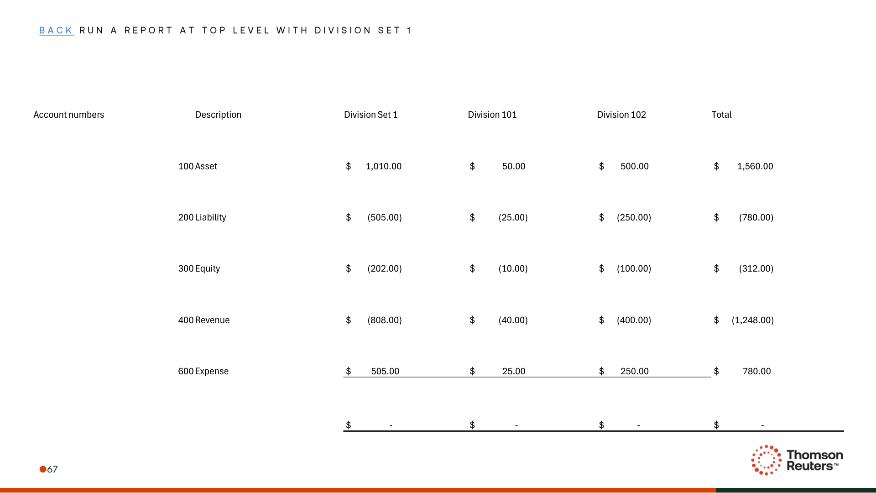
Figure: PDF page 71
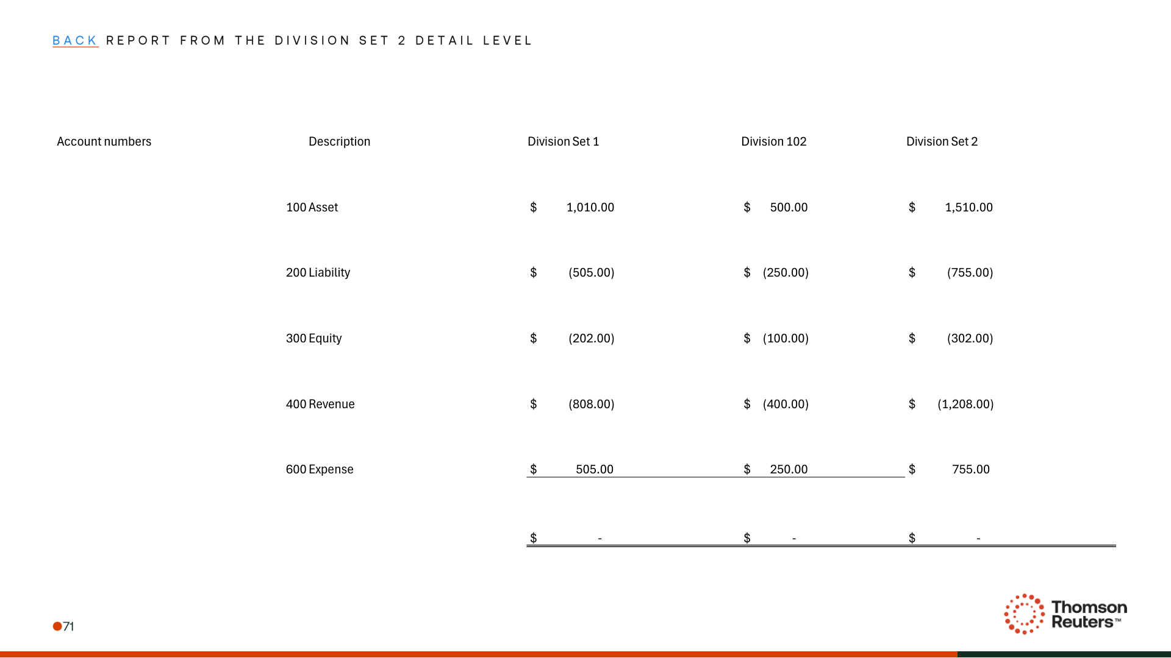
Figure: PDF page 72
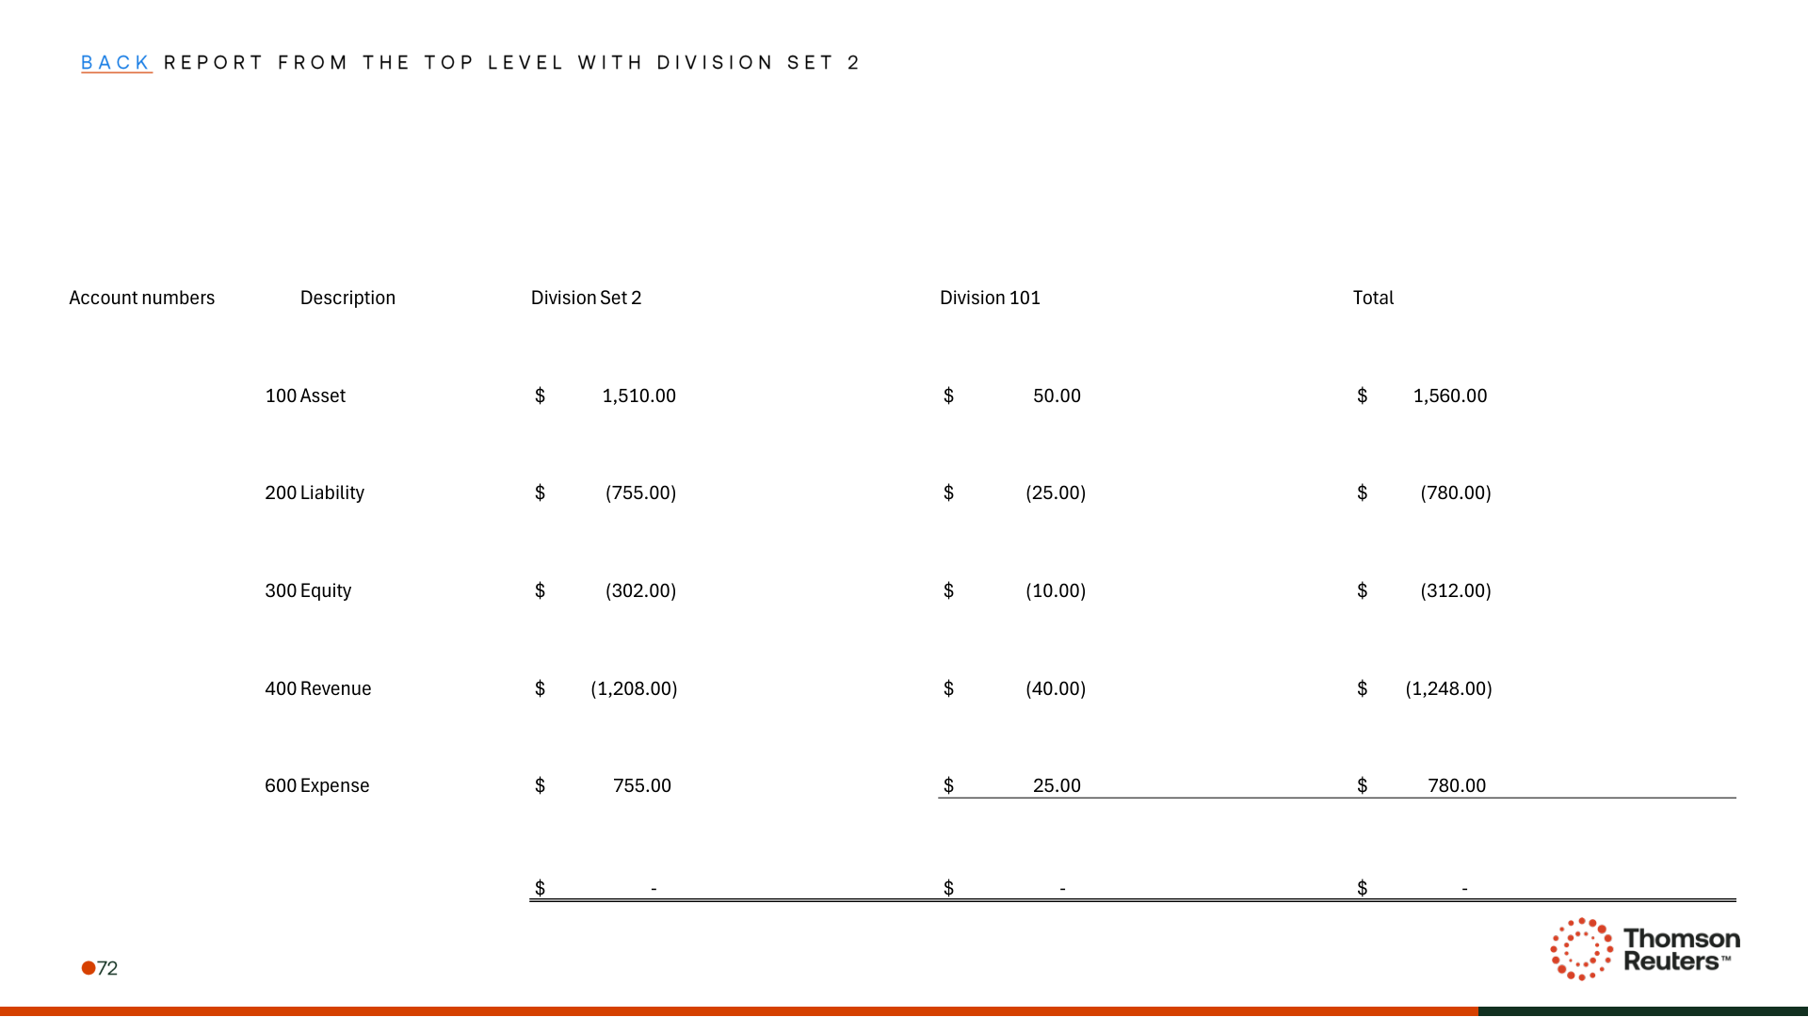

Appendix: Links
ADO Epic Link: https://dev.azure.com/tr-tax/TaxProf/_workitems/edit/4233646

